**TASK-3**

Configuration of basic switch setup using Huswel/Cisco Network switch using cisco packet tracer

**STEP-1:**

1. Open cisco packet tracer
2. Add devices:

* Drag and drop a cisco switch onto the workspace
* Drag and drop two or more PCs onto the workspace

1. Connect devices:

* Use the connections option to select the copper straight through cable
* Connect each PC to the switch using the fast ethernet ports (like PC0 to fast ethernet0/1, PC1 to fast ethernet0/2

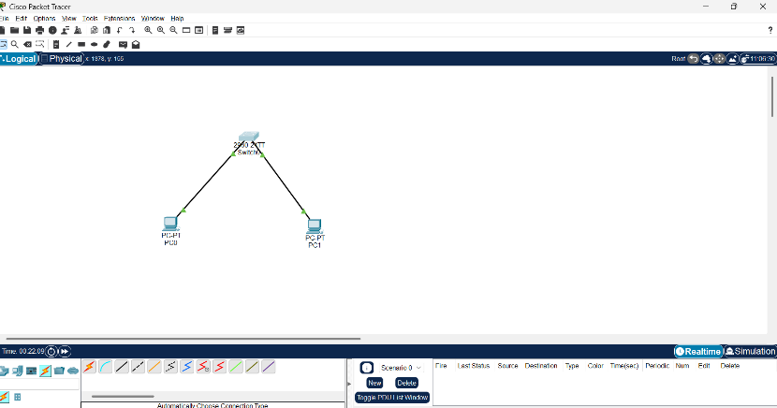

* FOR PC0

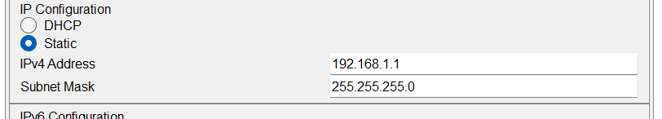

* FOR PC1

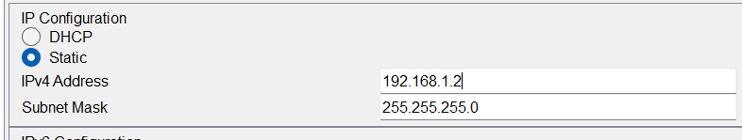

**STEP-2:**

**1**. Open the CLI of the Switch

* Click on the switch → Go to the CLI tab.

2. Start entering the commands

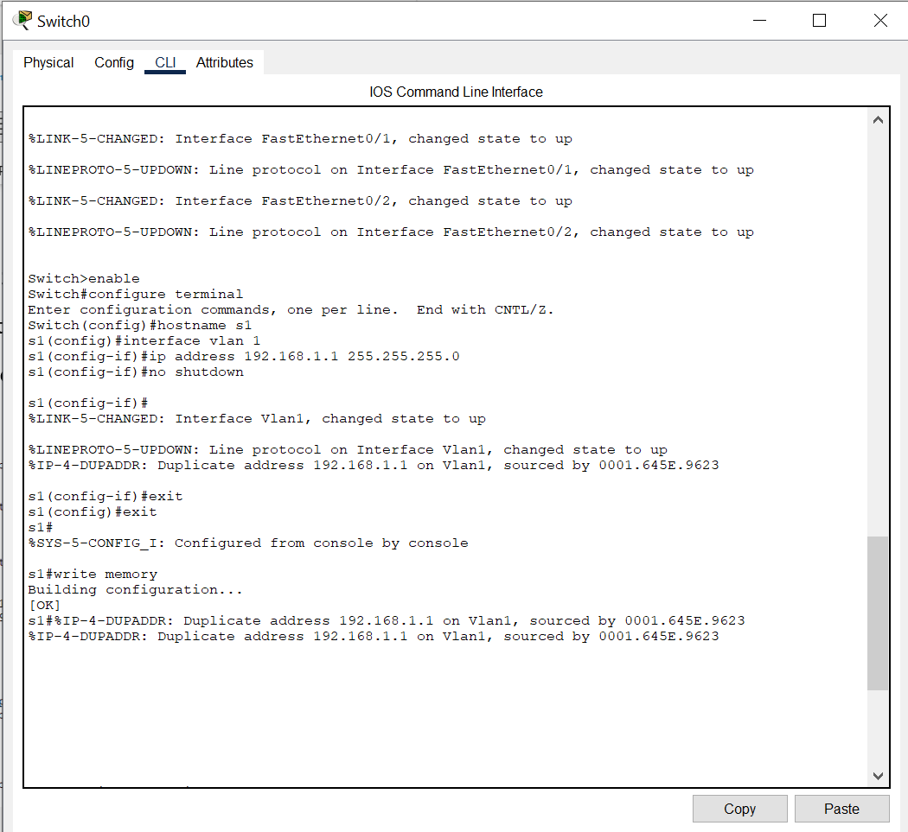

**STEP-3:**

**For PC0:**

1. Click PC0 → Desktop → IP Configuration.
2. Set:
   * IP address: 192.168.1.2
   * Subnet mask: 255.255.255.0
   * Default gateway: 192.168.1.1

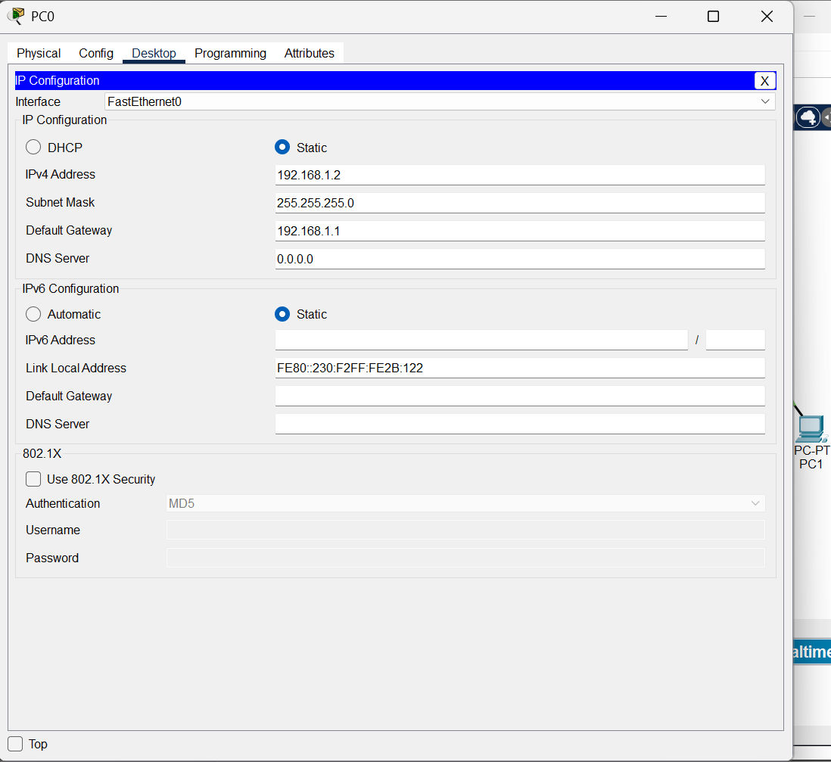

**For PC1:**

1. IP address: 192.168.1.3
2. Subnet mask: 255.255.255.0
3. Default gateway: 192.168.1.1

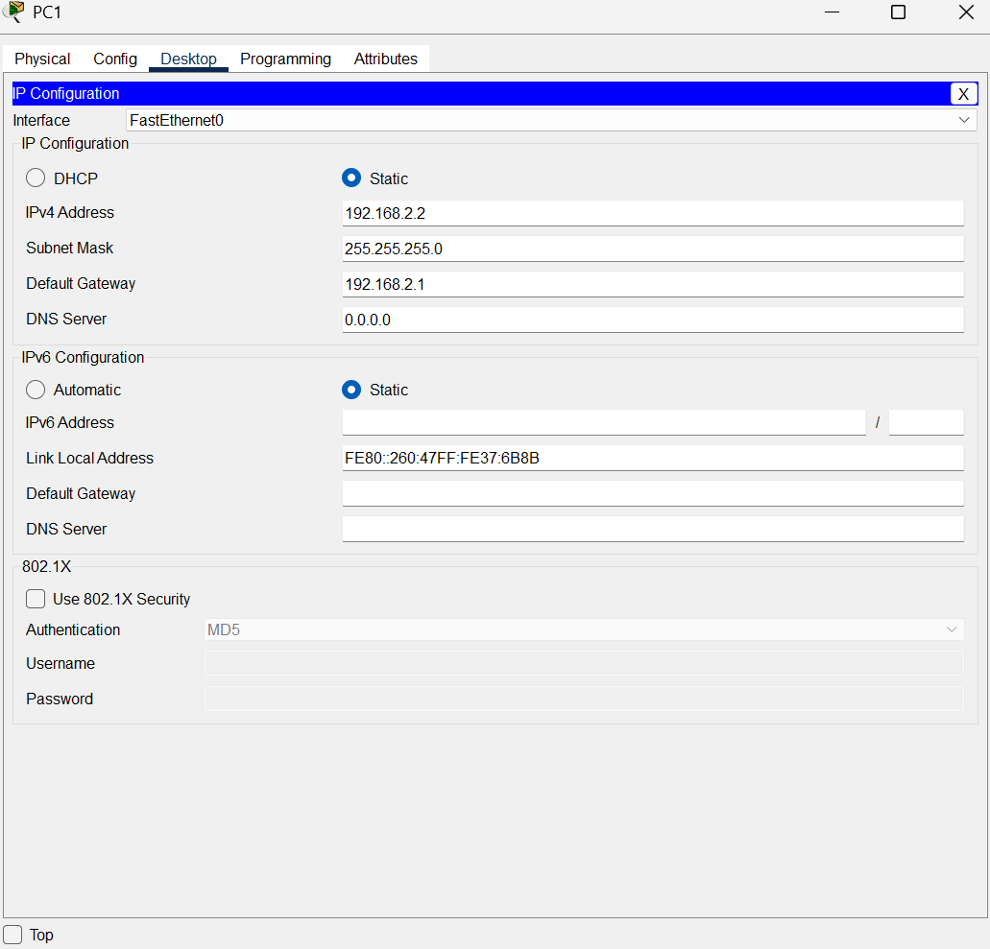

**STEP-4:**

1.Testing Connectivity

* Ping between PCs

Open the command prompt on one of the PCs like PC0

Use ping command to check the connectivity to the other pC

